
The University Of Azad Jammu &
Kashmir,Muzaffarabad

Name: Hassan Gillani
Roll NO: 2024-SE-42
Course Code: CS-2203
Submission Date:27thMay,2026
Course Title:Computer Networks
Instructor Name: Engr. Asma Javaid

Department Of Software Engineering

Star Topology Using Switch

• Introduction
A star topology is a network configuration in which all devices (computers, printers, etc.) are connected to a central device called a switch. The switch manages communication between devices, making the network efficient, reliable, and easy to troubleshoot.

To design and configure a star topology using a switch and assign IP addresses to ensure communication between devices.

• Procedure o Step 1: Open Simulation Software
Open Cisco Packet Tracer and prepare a blank workspace for network design. o Step 2: Add Devices (Star Layout)
Place one switch at the center and add multiple PCs around it to form a star topology. o Step 3: Connect Devices to Switch
Connect each PC to the switch using straight-through cables (all links should turn green). o Step 4: Configure IP Addresses
Assign unique IP addresses to each PC within the same network (e.g., 192.168.1.x with subnet mask 255.255.255.0). o Step 5: Verify Connectivity Using Ping and Packet Simulation
Use the ping command between PCs and also test using simulation mode to observe packet flow through the switch.

Step 1 & 2: Adding Switch and PCs (Star Layout)
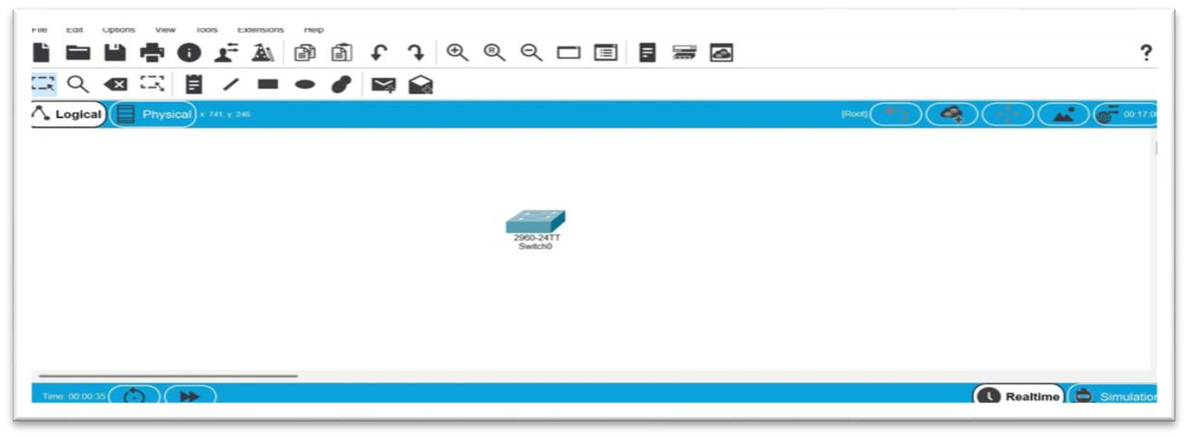
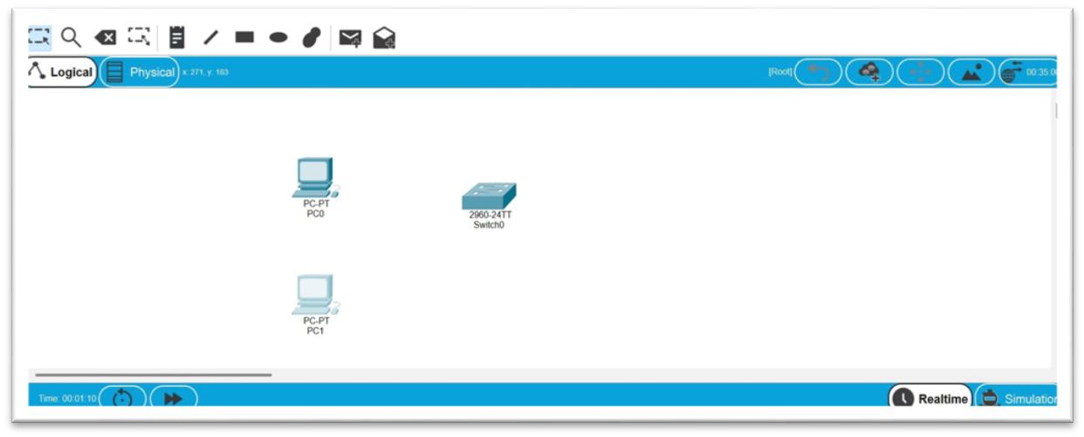

Step 3: Connecting Devices to Switch
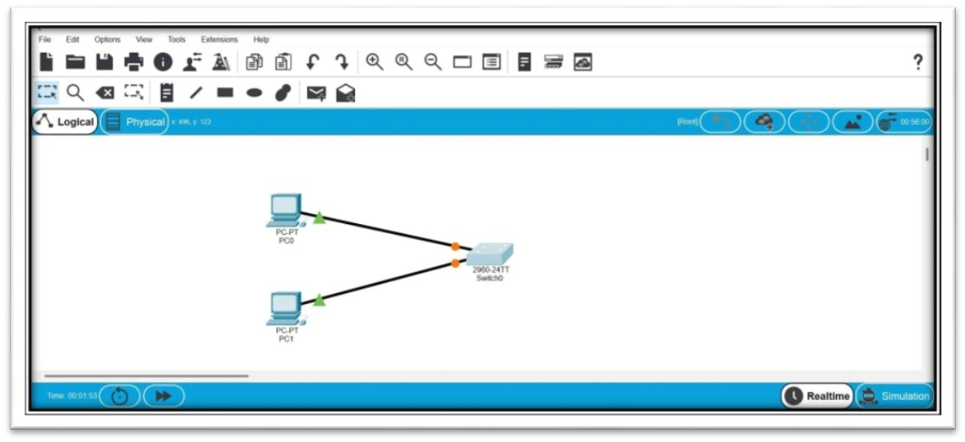

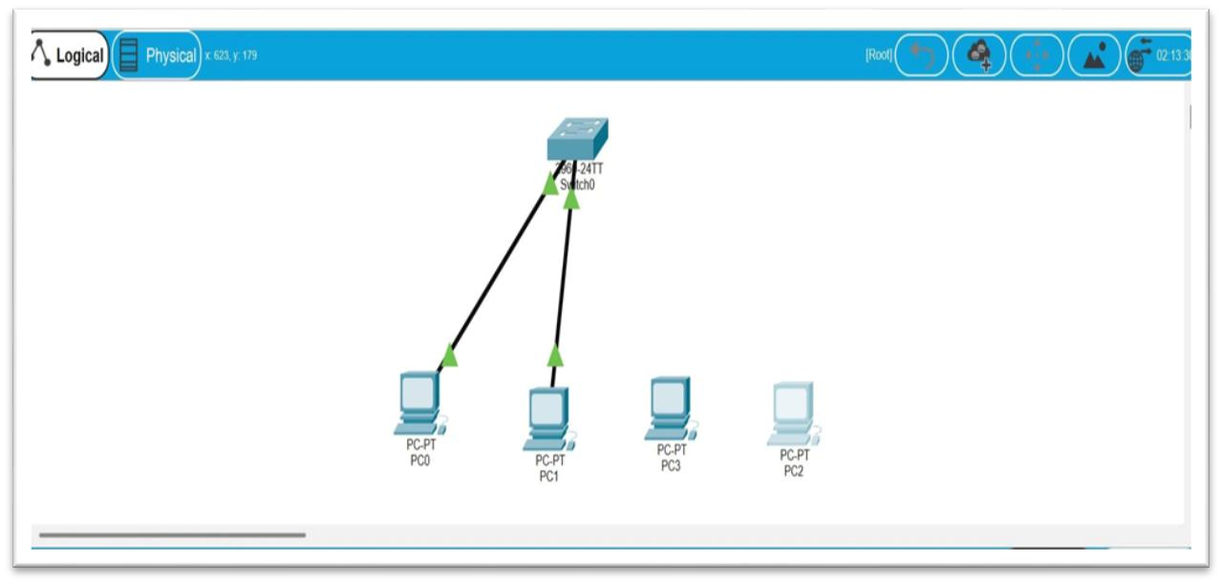

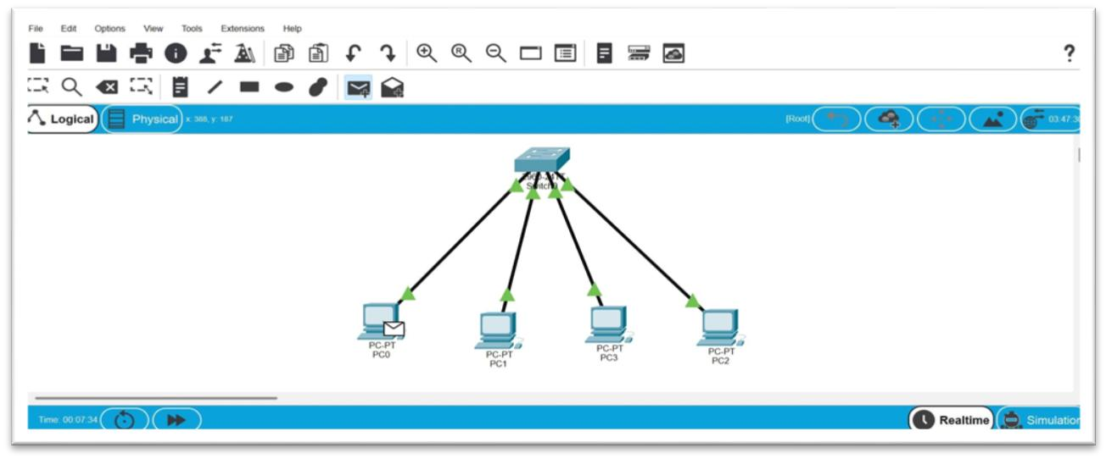
Step 4: Configuring IP Addresses (Multiple PCs)
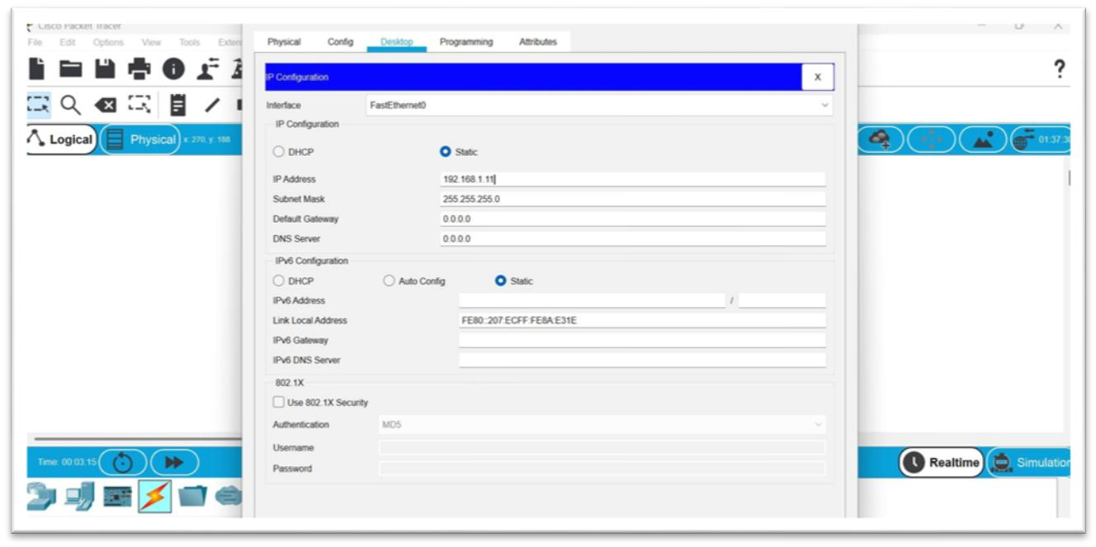

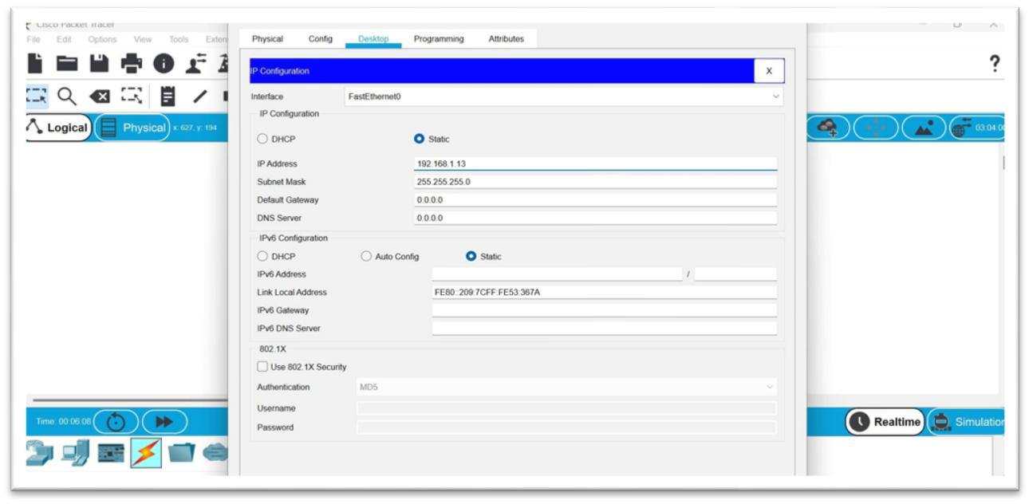

Step 5: Ping Results and Packet Simulation
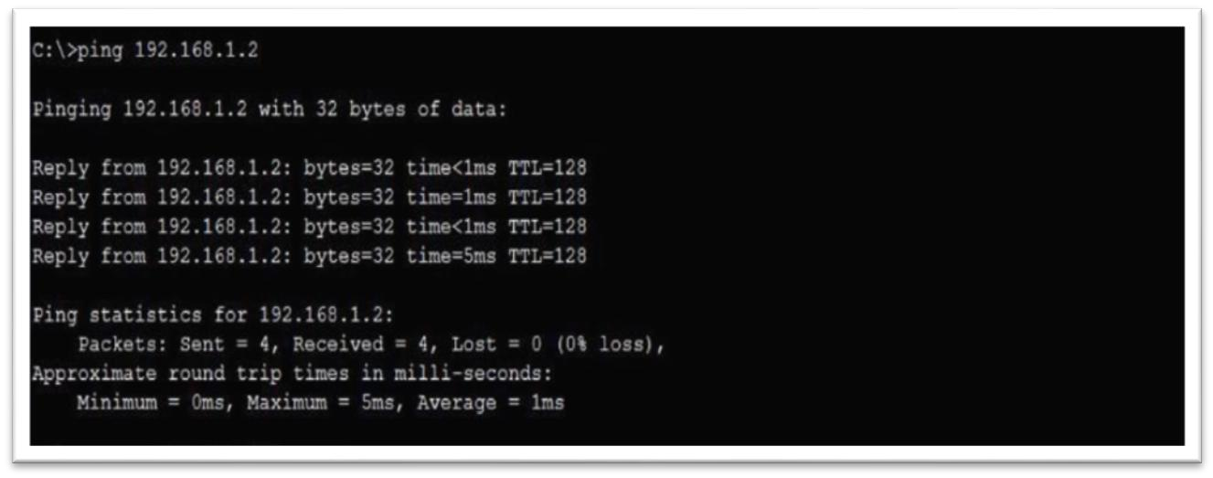

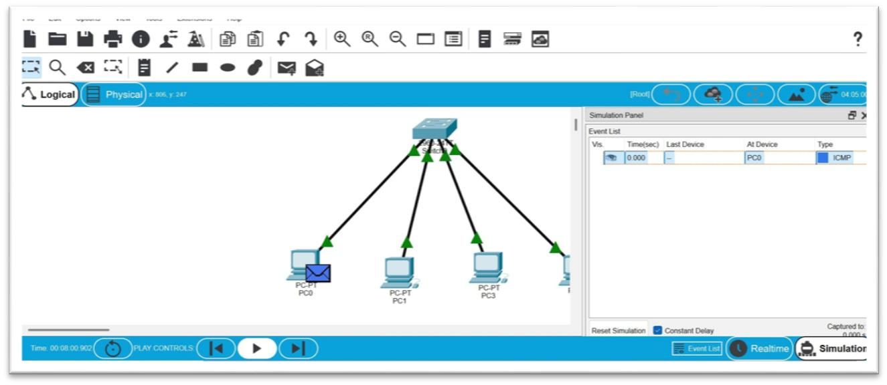

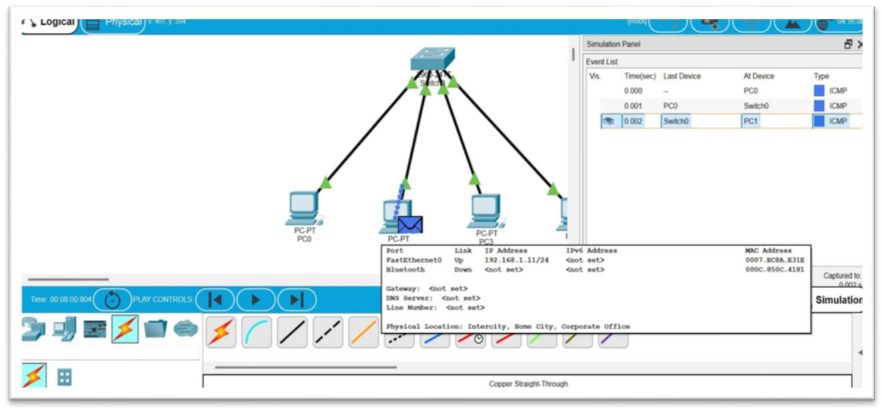
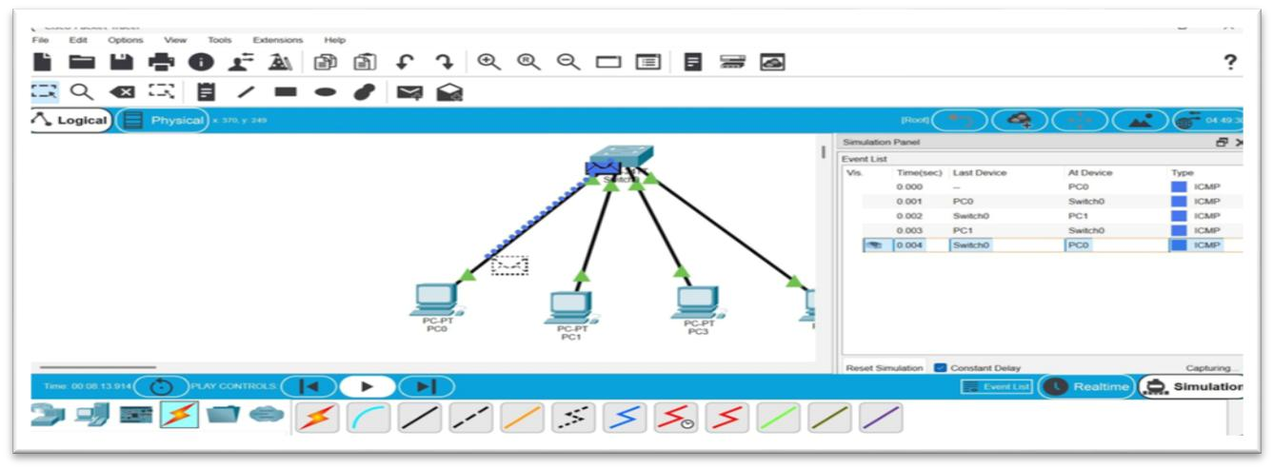

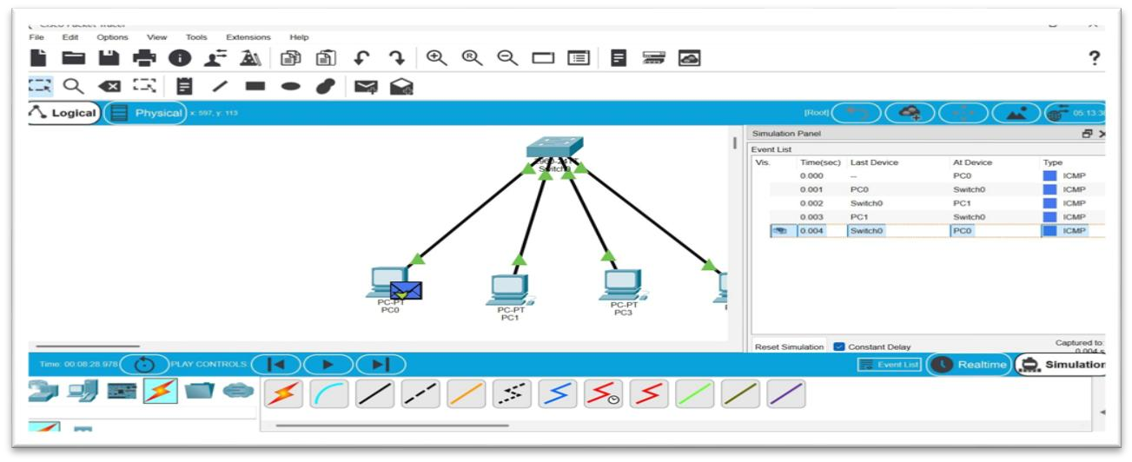

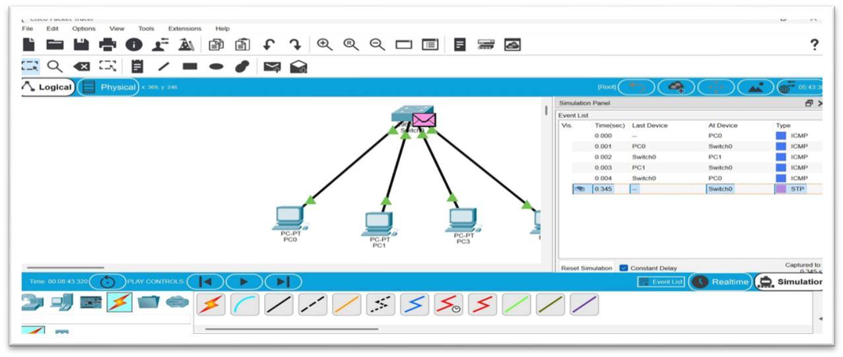

Conclusion
The star topology using a switch provides efficient communication and centralized control. It is easy to manage and troubleshoot, making it one of the most commonly used network topologie.

